**Muhammad Abdullah**

**SE(4A) | 19F-0916**

Operating System Lab

Synchronization Mutex Locks, Semaphores, Conditional variables

**Question # 01**

**CPP CODE:**

**#include <iostream>**

**#include <pthread.h>**

**#include<unistd.h>**

**using namespace std;**

**//Question 1**

**int GlobalVariable;**

**pthread_mutex_t Locked;**

**pthread_cond_t Condition;**

**void* Recieved ( void* val)**

**{**

**string Convert = (char *) val;**

**cout<<"Message has been recieved : "<<Convert<<endl;**

**pthread_exit(NULL);**

**}**

**void* threadReleased()**

**{**

**pthread_mutex_lock (&Locked);**

**pthread_t thread;**

**char* Message = "Humpty Dumpty Sat On A Wall\nBecause usko ghar nahi rehney detey ";**

**pthread_create(&thread,NULL,Recieved, (void *)Message);**

**pthread_join(thread,NULL);**

**++GlobalVariable;**

**pthread_cond_signal(&Condition);**

**pthread_mutex_unlock(&Locked);**

**}**

**void* Sent(void * val)**

**{**

**threadReleased();**

**}**

**void* threadJoin()**

**{**

**pthread_mutex_lock(&Locked);**

**while(GlobalVariable==0)**

**{**

**pthread_cond_wait(&Condition,&Locked);**

**pthread_mutex_unlock(&Locked);**

**}**

**}**

**int main()**

**{**

**pthread_t thread;**

**pthread_create(&thread,NULL,Sent,NULL);**

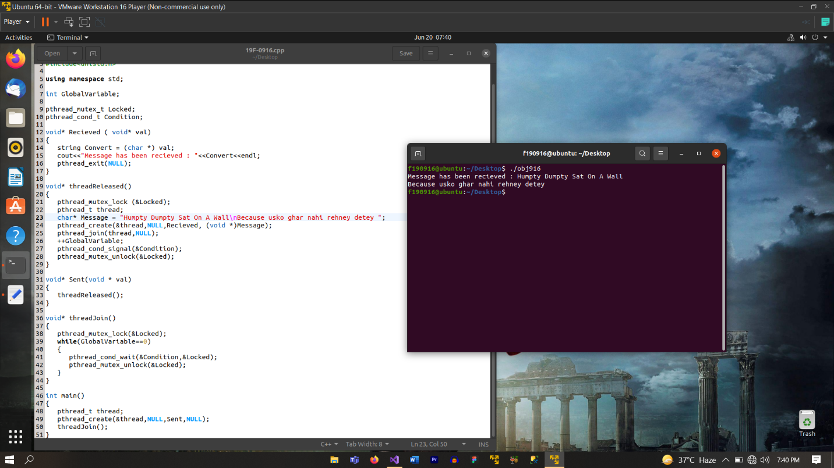 **threadJoin();**

**}**

**Question # 02**

**Cpp code:**

**#include <iostream>**

**#include <pthread.h>**

**#include<unistd.h>**

**using namespace std;**

**// Question 2**

**pthread_mutex_t Locked;**

**void* Alpha (void * val)**

**{**

**pthread_mutex_lock(&Locked);**

**int OB=0,NB=0,CB=100,AB=10000;**

**OB=CB;**

**NB=OB+AB;**

**CB=NB;**

**cout<<"We are in Parent Thread" <<endl;**

**cout<<"Balance After Parent Deposited it :" << CB << endl;**

**pthread_mutex_unlock(&Locked);**

**pthread_exit(NULL);**

**}**

**void* Bravo (void * val)**

**{**

**pthread_mutex_lock(&Locked);**

**int OB=0,NB=0,CB=100,AB=5000;**

**OB=CB;**

**NB=OB+AB;**

**CB=NB;**

**cout<<"We are in Brother Thread" <<endl;**

**cout<<"Balance After Brother Deposited it :" << CB << endl;**

**pthread_mutex_unlock(&Locked);**

**pthread_exit(NULL);**

**}**

**void* Charlie (void * val)**

**{**

**pthread_mutex_lock(&Locked);**

**int OB=0,NB=0,CB=100,AB=5500;**

**OB=CB;**

**NB=OB+AB;**

**CB=NB;**

**cout<<"We are in Cousin Thread" <<endl;**

**cout<<"Balance After Cousin Deposited it :" << CB << endl;**

**pthread_mutex_unlock(&Locked);**

**pthread_exit(NULL);**

**}**

**int main()**

**{**

**pthread_mutex_init(&Locked,NULL);**

**pthread_t FirstThread;**

**pthread_t SecondThread;**

**pthread_t ThirdThread;**

**pthread_create(&FirstThread,NULL,Bravo,NULL);**

**pthread_create(&SecondThread,NULL,Alpha,NULL);**

**pthread_create(&ThirdThread,NULL,Charlie,NULL);**

**pthread_join(FirstThread,NULL);**

**pthread_join(SecondThread,NULL);**

**pthread_join(ThirdThread,NULL);**

**}**

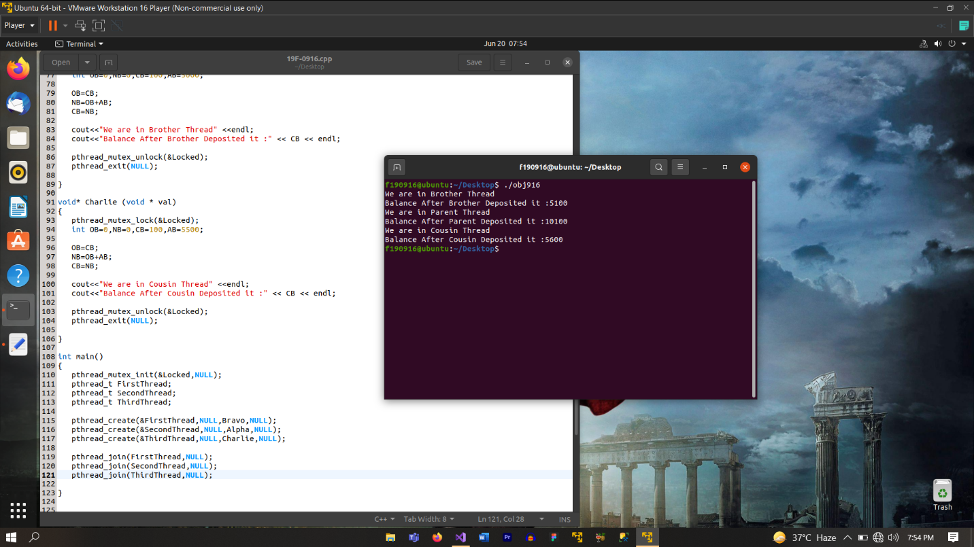

**Question # 03**

**Cpp Code:**

**#include <iostream>**

**#include <pthread.h>**

**#include<unistd.h>**

**using namespace std;**

**#include <semaphore.h>**

**sem_t Semaphore;**

**int GlobalVariable=1;**

**void* Alpha(void* val)**

**{**

**sem_wait(&Semaphore);**

**int temp = GlobalVariable;**

**temp++;**

**GlobalVariable=temp;**

**cout<<" Global Variable in Thread 1 : "<< GlobalVariable << endl;**

**sem_post(&Semaphore);**

**pthread_exit(NULL);**

**}**

**void* Bravo(void* val)**

**{**

**sem_wait(&Semaphore);**

**int temp = GlobalVariable;**

**temp--;**

**GlobalVariable=temp;**

**cout<<" Global Variable in Thread 1 : "<< GlobalVariable << endl;**

**sem_post(&Semaphore);**

**pthread_exit(NULL);**

**}**

**int main()**

**{**

**sem_init(&Semaphore,0,1);**

**pthread_t FirstThread;**

**pthread_t SecondThread;**

**pthread_create(&FirstThread, NULL, Alpha, NULL);**

**pthread_create(&SecondThread, NULL, Bravo, NULL);**

**pthread_join(FirstThread,NULL);**

**pthread_join(SecondThread,NULL);**

**cout<<"After Completion, Global Variable Becomes : "<< GlobalVariable<<endl;**

